Final Trial Report
BIOIGNITE FERTILIZERS
JOHN LATHOURAS 0418988985



Title – To assess the benefits of Chicken Manure fertiliser in sugar cane grown in the Bundaberg district.

Aim – To compare a manure fertiliser product (S2A) to the farmers standard in a sugar cane crop cycle.

Summary
In the S2A plot, 210tc/ha was returned compared to a cane yield of 133tc/ha in the standard. The S2A treatment cane yield in combination with a ccs of 15.16 resulted in a sugar yield of 31.8ts/ha. The control plot cane yield in combination with a higher ccs of 15.56 resulted in a sugar yield of 20.5ts/ha.
Whilst the magnitude of the result in this trial is impressive it has to be understood that this is a trial undertaken over a standardised area of 1 ha. It could however, be expected that additions of S2A to current fertiliser regimes will increase sugar yields far in advance of the cost of the S2A addition.

Contents
Summary 2
1.0 Outline 4
2.0 Treatments 4
3.0 Method 4
3.1 Trial details 5
3.2 Trial Location (24.70858°S, 152.19786°C) 5
3.3 Soil Map 6
3.4 Trial Map 6
4.0 Results 7
4.1 Soil Sample data (pre-trial) 7
4.2 Solvita respiration 8
4.3 Establishment counts (12 weeks post plant) 8
4.4 Stalk Heights 9
4.5 Leaf Analysis 10
4.6 Stalk weights 10
4.7 Stalk number per meter 11
4.8 Field cane yields as of August 2025. 11
4.9 NIR ccs 12
4.10 Final harvested yield 12
5.0 Discussion 13
6.0 Conclusion 13
7.0 Photos 14
Raw Data and statistics 16

1.0 Outline
A field trial was established, and a manure fertiliser product called S2A was applied in addition to the standard fertiliser being used by the grower. This treatment was then compared to the standard fertiliser only treatment. All other management activities are the same for each treatment area. The following assessments were made and are presented in this report
- Soil sample taken and recommendation for growers standard prior to commencement of trial.
- Establishment counts to determine uniformity.
- Solvita assessment prior to commencement of trial and at 6 and 12 months.
- Growth data from 5 stalks/treatment (grand phase Jan – Aug)
- Leaf analysis (April 2025)
- Harvest data (field brix and biomass and harvested biomass and mill ccs.

2.0 Treatments

T1 – Control - growers standard,
T2 – Growers standard plus 1t S2A/ha applied after fertilising

3.0 Method
In the S2A treatment, after the growers standard fertiliser was applied, the S2A was applied over the row at a rate of 1t S2A/ha. This area was then cultivated to incorporate the S2A fertiliser.
Assessment within this trial were made utilising the completely randomised block design, where replicates are taken randomly from within the one block. For this reason it was essential to determine block variability prior to taking measurements.
- Prior to taking soil samples it was determined from Queensland Globe that the whole of the block into which the trial would be placed was all of a very similar soil type. Soil samples were taken randomly across the block and bulked into one container. A single soil sample was taken from this bulked mass and was sent away for analysis.
- Solvita sampling was collected randomly from the top 10cm of soil. It was bulked and then a single subsample was taken from this. It was sent away to the EAL laboratory for assessment.
- Establishment was determined at 2 to 4 leaf stage (12 weeks) 26/11/24. Total shoot counts from 10 randomly selected 1M lengths of row within each treatment area were assessed.
- In January, 5 random sticks/treatment were selected, and a wooden peg was put into the ground just adjacent to each stick. Sticks heights were taken from January to August on a monthly basis, measuring height from the top of the peg to the cane growing point.
- Tissue samples were taken from near these 5 data collection points.
- Pre harvest biomass was determined by cutting the 5 sticks being measured for height and weighing these to determine a final mean weight per treatment.
- 6 sticks per treatment were taken to the SRA NIR lab for pre harvest assessment of ccs.
- From these data statistics were conducted using Excel one way ANOVA.
- At harvest each treatment plot was mechanically harvested and separated into cane bins with separately consigned mill tickets for each treatment. Miil ccs was collected from sample data corresponding to consignment tickets.

3.1 Trial details
- Location - BSL’s Johnsons farm in Block 5A
- Variety - Q208.
- Date planted - 06/09/24. (Flowphos KZ applied at 30l/ha)
- Date fertilised - 14/11/24 (Dunder) and 27/11/2024 (CK700)
- Fertiliser used as growers std – Dunder (6200l/ha), CK700 300kg/ha)
- S2A applied 27/11/24 straight after the CK700
- Trial Harvest date 09/11/25

3.2 Trial Location (24.70858°S, 152.19786°C)

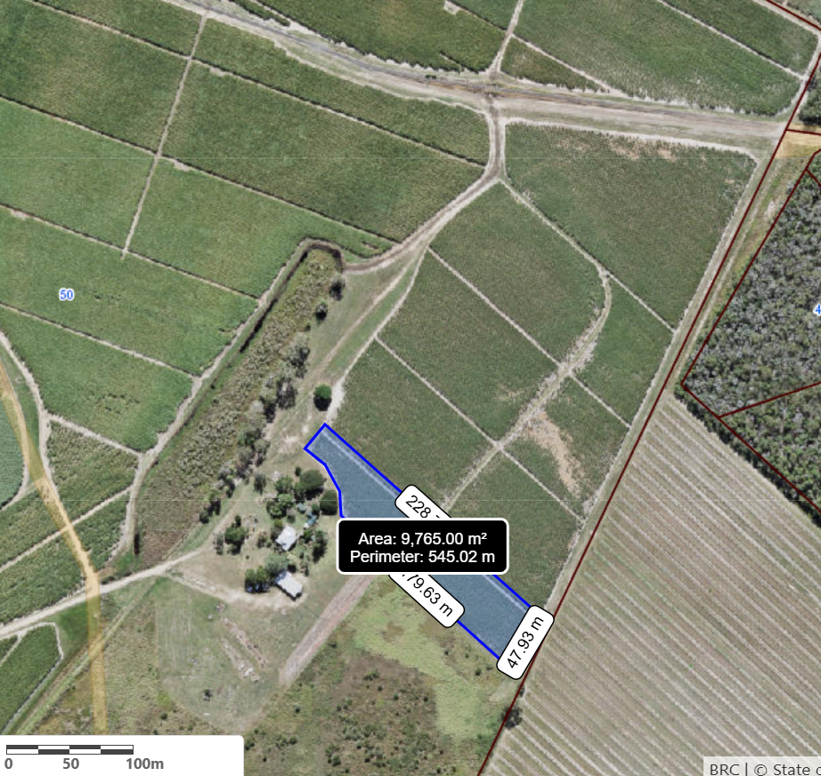

Photo 1. Trial location. The shaded area is the area where S2A has been applied at 1t/ha. The 28rows next to the shaded area is the control (growers standard only).

3.3 Soil Map

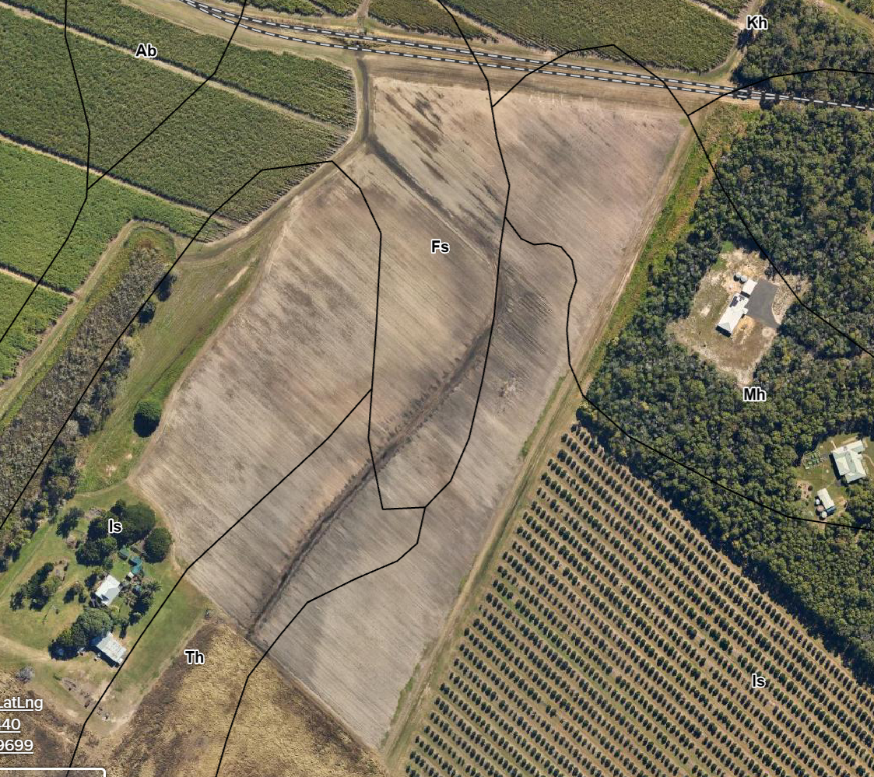
Photo 2. Soils within the trial Block - 66% Isis and 33% Theodolite.

3.4 Trial Map

T1 28 Rows – S2A | T2 28 Rows of control (growers std)

4.0 Results

4.1 Soil Sample data (pre-trial)

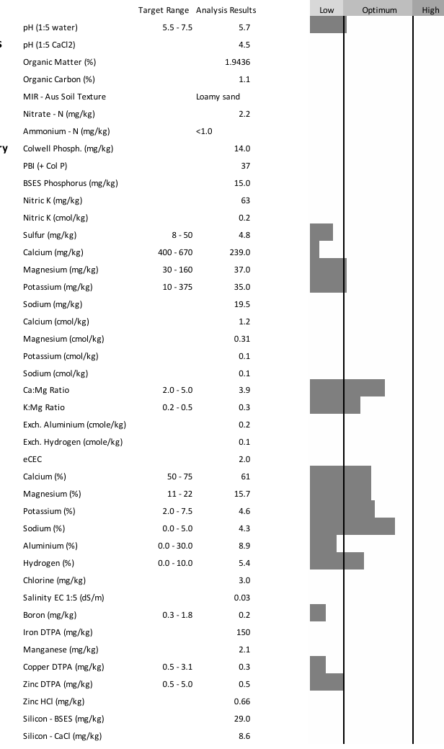

The soil data pre planting identifies that the block required,
Lime applied at 2t/ha
N – 120kg/ha
P – 15kg/ha
K – 100kg/ha
S, Ca and Mg were supplied in the lime, dunder and flowphos

4.2 Solvita respiration

The pretrial solvita respiration analysis highlights that the CO2 mg/kg present prior to the application of S2A was 88mgCO2/kg soil. This is considered to represent medium microbial activity. At 6 and 12 months further Solvita analyses were taken these were as follows

Table 1. Solvita results mg/kg CO2.
Treatment | 6 months | 12 months
Control | 19 | 22
S2A | 12 | 11

The Solvita testing based on the burst method resulted in both the control and treated plots returning respiration amounts representative of low microbial activity at both 6 and 12 months.

4.3 Establishment counts (12 weeks post plant)

Fig 1. Establishment shoot counts week 12. (LSD P = 0.05 = NS)

There was no significant difference in the numbers of shoots/m randomly taken from within each treatment area. This highlights that established sugarcane populations were statistically similar in each treatment area.

4.4 Stalk Heights

Fig 2. Stalk height comparison over time

Fig 3. Final mean stalk height (Lsd P=0.05 = NS)

There was no significant difference in the mean height of the measured stalks in August 2025.

4.5 Leaf Analysis

Table 2. Percentage of major nutrient in leaf analyses
Parameter | Control | S2A
Total Carbon | 47.6 | 47.3
Total Nitrogen | 2.14 | 2.19
Crude protein | 13.4 | 13.7
Sodium | 0.01 | 0.02
Potassium | 1.55 | 1.39
Calcium | 0.42 | 0.46
Magnesium | 0.22 | 0.24
Phosphorous | 0.23 | 0.23

All nutrients measured are within optimal levels for sugar cane. There is very little difference between the control and treated samples

4.6 Stalk weights

Fig 4. Final stalk weights (kg). (LSD P=0.05 = 0.0002kg)

The mean weight of the final stalk weights was significantly heavier in the S2A treatment compared to the control.

4.7 Stalk number per meter

Fig 5. Mean stalk number per meter. (LSD P = 0.05 = NS)

There was not a significant difference in the number of stalks per meter between the control and treated plots.

4.8 Field cane yields as of August 2025.

Fig 6. Field cane yield august 2025.
The field yield was determined from multiplying mean stalk weight by mean stalk number by running meters in 1ha (5970m at 1.675m row width)
From this it can be seen that 177tc/ha could be estimated from the treated plot and 127tc/ha from the control

4.9 NIR pre harvest ccs data

Fig 7. Pre harvest NIR ccs’s
NIR shows greater NIR ccs in the control compared to the S2A treatment

4.10 Final harvested yield

Table 3. Final Harvested data from the trial site
Treatment | Area | Tonnes | ccs | tc/ha | ts/ha
S2A | 0.9765 | 205.05 | 15.16 | 210 | 31.8
Control | 1.01 | 133.24 | 15.56 | 132 | 20.5

Fig 8. Harvest cane yields November 2025
77tc/ha more was returned from the S2A treated plot compared to the control

5.0 Discussion
Measurement of stalk heights over the 7 month time period from January to August 2025 showed that the S2A plot had a trend of consistently taller stalks.
Significantly heavier stalks were recorded in the plot where S2A was applied in the final field assessment undertaken taken in August 2025. An assessment of the stalk weight and stalk number enabled a field calculation of cane yield to be determined at this time. This assessment showed that in August, 177tc/ha was present in the plot where S2A was applied compared to 127tc/ha in the control standard.
Final harvest of the block occurred 3 months after the final field assessments. In the S2A plot, 210tc/ha was returned compared to a cane yield of 133tc/ha in the standard. The S2A treatment cane yield in combination with a ccs of 15.16 resulted in a sugar yield of 31.8ts/ha. The control plot cane yield in combination with a higher ccs of 15.56 resulted in a sugar yield of 20.5ts/ha.
The assessment of tissue undertaken in April did not show any definitive difference between the control and S2A plots. This is not unexpected since the final yields achieved in the control, even though lower than that of the S2A plot, was still very good for a crop of spring planted Q208 in the Bundaberg district.
By reviewing the field and harvested yields as well as ccs data, it could be speculated that the cane in the S2A plot was still growing throughout the 3 months period from August to November. This is significant because conditions during this period of time were mild and dry and yet the S2A treatment was still able to accumulate approximately 20 – 25tc/ha.

6.0 Conclusion
Solvita assessments undertaken at 6 and 12 months did not show any difference between treatments. Whilst this assessment is a cheaper less accurate but valid assessment of overall CO2 respiration a more complete and accurate assessment of the microbial activity in each plot should be undertaken in the 1st ratoon crop.
Whilst the magnitude of the result in this trial is impressive it has to be understood that this is a trial undertaken over a standardised area of 1 ha. It could however, be expected that additions of S2A to current fertiliser regimes will increase sugar yields far in advance of the cost of the S2A addition.
Under the current reef regulations S2A is not considered a recordable N or P input. For this reason it could be speculated that applications of S2A would be potentially attractive to sugar cane growers limited by further N and P inputs due to current N and P budgetary implications.
This trial will continue and results from ratoons will continue be added to these data sets.

7.0 Photos

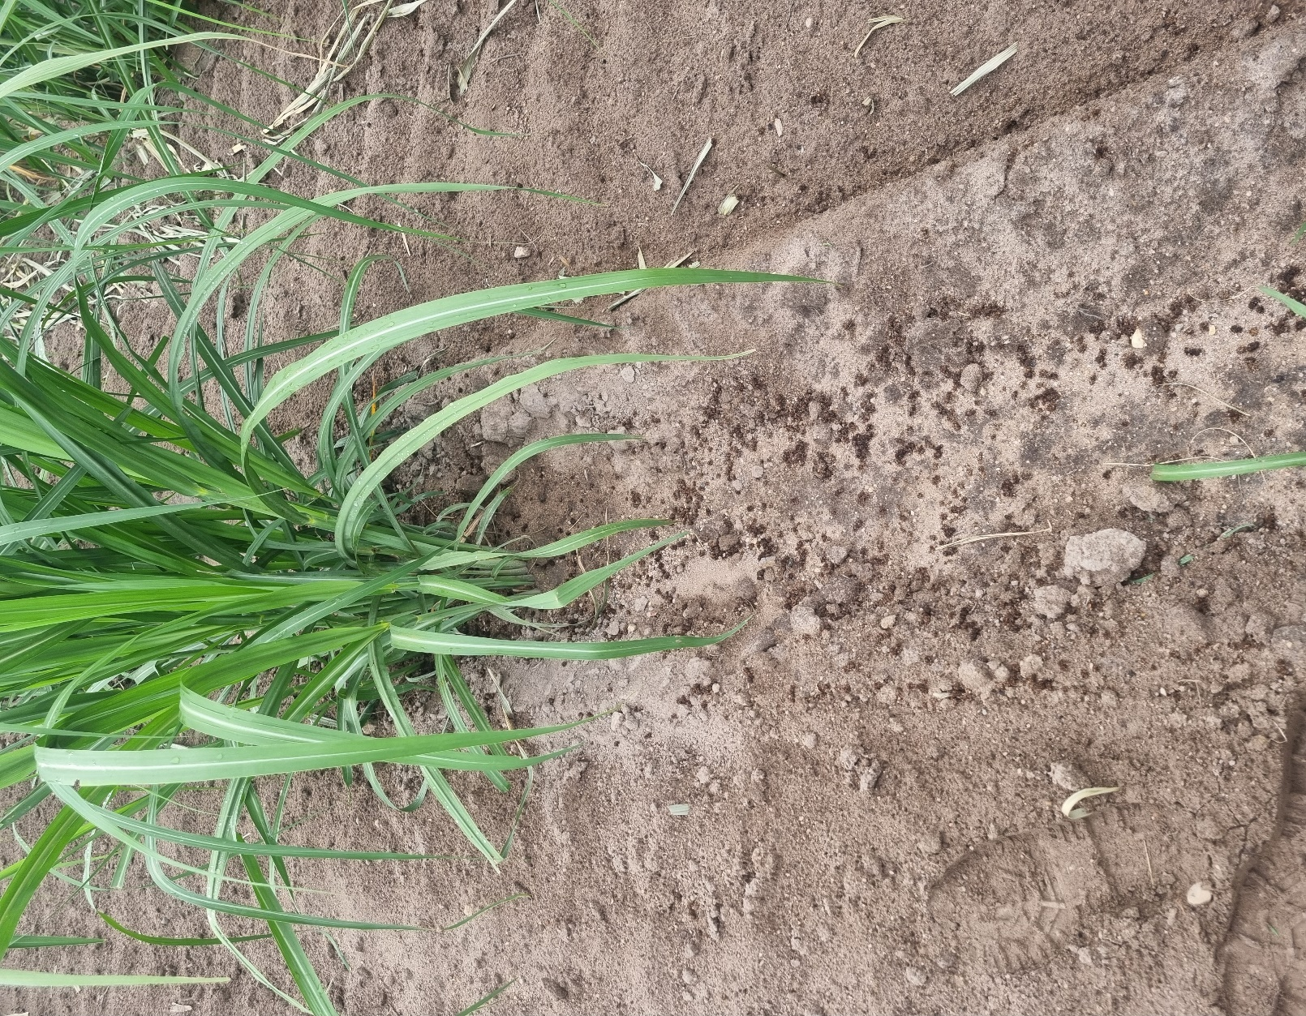

Photo 1. 1T/ha S2A fertiliser applied into the furrow before cultivation to incorporate.

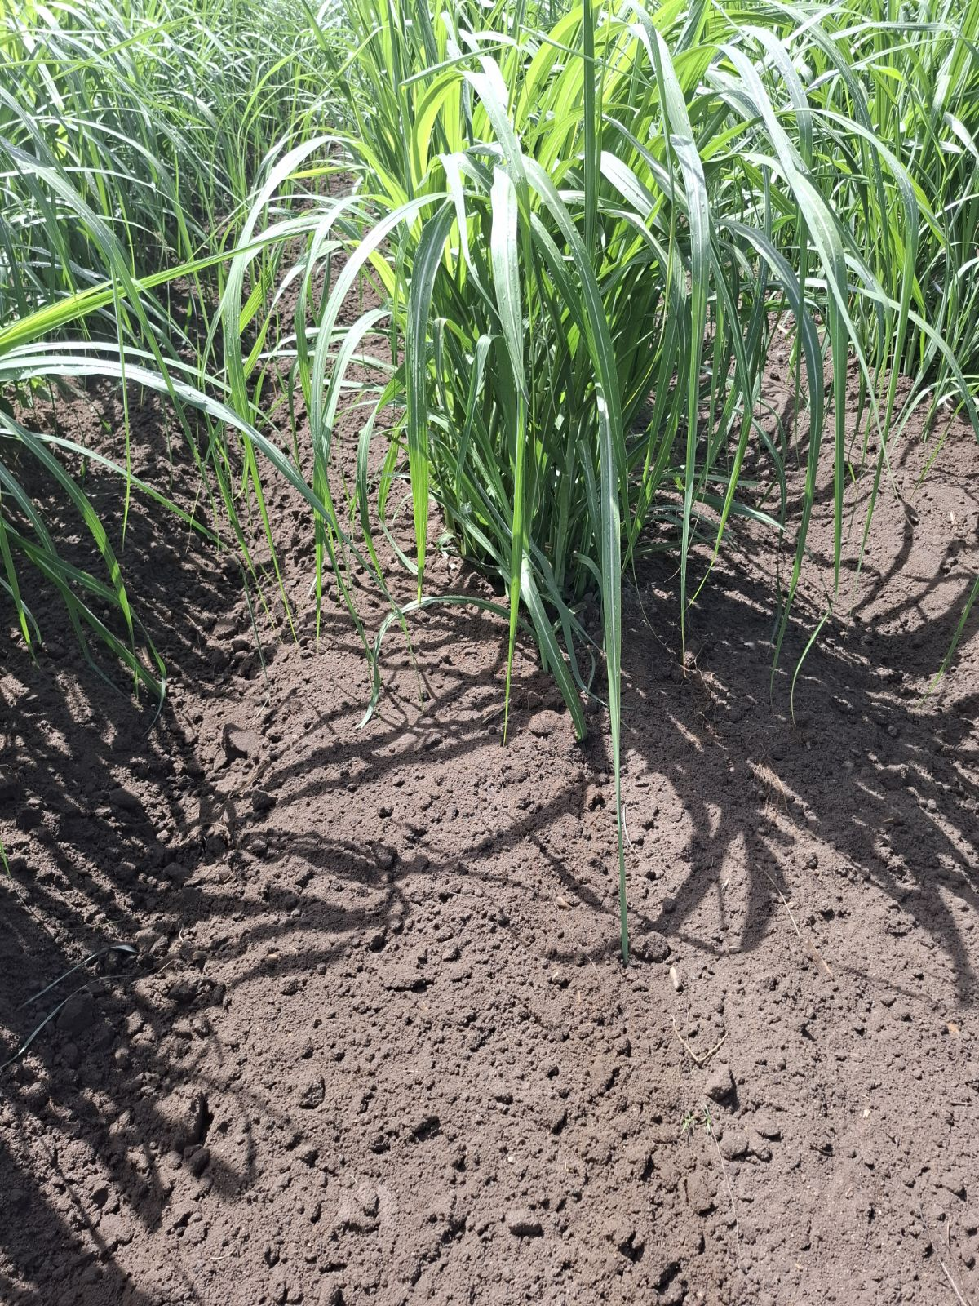

Photo 2. Same site in the block after the S2A has been incorporated into the profile.

Raw Data and statistics

Establishment shoot counts
 | S2 | Control
1 | 32 | 24
2 | 37 | 37
3 | 22 | 32
4 | 37 | 20
5 | 26 | 20
6 | 28 | 34
7 | 19 | 19
8 | 31 | 33
9 | 23 | 25
10 | 33 | 23
 | 288 | 267
 | 28.8 | 26.7

Anova: Single Factor
SUMMARY
Groups | Count | Sum | Average | Variance
S2 | 10 | 288 | 28.8 | 39.06667
Control | 10 | 267 | 26.7 | 44.45556
ANOVA
Source of Variation | SS | df | MS | F | P-value | F crit
Between Groups | 22.05 | 1 | 22.05 | 0.528003 | 0.476792 | 4.413873
Within Groups | 751.7 | 18 | 41.76111
Total | 773.75 | 19

