
The influence of a range of Microbial products on a crop of Dryland Wheat
Moonbi Demonstration Work 2025
Report compiled
by
John Lathouras Bio Ignite Fertilisers Pty Ltd
and
Ian Dart Stillwater Ag Assist



Summary
- In demonstration 1 it was observed that all plots where the Moonbi Blend was applied achieved grain yields greater than that of the standard.
- The total nitrogen % was greater in the plots where Moonbi Blend was applied.
- There appears to be a beneficial effect on soil exchangeable sodium % (ESP) with using increased rates of Moonbi Blend fertiliser. The calcium in the MB fertiliser helps to displace sodium and hence reduce sodicity. This has a benefit on the ability of the soil to become friable and hence allow for better nutrient and water utilisation from unrestricted root growth in less compacted profiles.

Contents
1.0 Background 4
2.0 Objective 4
3.0 Aim 4
4.0 Method 4
4.1 Demonstration 1. The influence on yield of Bioignite Fertilisers “ Moonbi Blend” (MB) compared to the standard. 6
4.2 Demonstration 2. The influence on yield using Groundworks-Bio Microbials (GW) applied to seed pre plant compared to the standard. 8
4.3 Trial site 9
4.4 Soil Type within the demonstration area 10
4.5 Treatment map 11
4.6 Demonstration Details 12
5.0 Results 13
5.1 Soils data 13
5.2 Grain sample data 14
5.3 Grain Yield 15
6.0 Summary Points 16
Appendix - Raw data 17

1.0 Background
Bioignite Fertilisers have developed a microbial product marketed as Groundworks-Bio, it can be used directly as a soil additive at planting or added to pelletised composted manure products and hybrid fertilizer blends. BioIgnite fertilisers can create specific blends of pelletised composted animal manures and infuse this with microbes it has developed which are indigenous to Australia.
Other trial work has been undertaken over the past 3 years in a range of cropping systems including sugar cane and leafy greens which have determined that BioIgnite S2A provides a cost effective means of enhancing overall soil health and crop nutrition.

2.0 Objective
To determine and demonstrate the influence that BioIgnite Fertiliser’s microbials have in a dryland wheat cropping system in the Moonie district.

3.0 Aim
The first demonstration aim was to compare BioIgnite Fertiliser ‘Moonbi Blend’ with added Groundworks-Bio microbials and composted chicken manure specially developed for a wheat system. This blend was called the “Moonbi blend” (named after the property on which the trials were conducted). This was compared to the growers standard method of providing nutrition.
The second demonstration aim was to apply Groundworks -Bio microbials to the seed itself immediately prior to planting and then compare this to the growers standard. In this case the demonstration area would not have the standard fungicide treatment applied to the area where microbes had been added to the seed.

4.0 Method
Large single plot treatments were used to demonstrate the influence of Bioignite Fertiliser products and rates. The grower used his own equipment, seed and fungicides.


4.1 Demonstration 1. The influence on yield of Bioignite Fertilisers “ Moonbi Blend” (MB) compared to the standard.
Treatment 1 – Growers standard
Lancer wheat planted with Starter Z applied at 30kg /ha. Fungicide was also applied at recommended rates.

Treatment 3 – Moonbi Blend Fertilizer applied at 30kg/ha. Seed treated with fungicide at recommended rates.

Treatment 4– Moonbi Blend Fertiliser applied at 50kg/ha. Seed treated with fungicide at recommended rates.

Treatment 5 – Moonbi Blend Fertiliser applied at 75kg/ha. Seed treated with fungicide at recommended rates.

Treatment 6– Moonbi Blend Fertiliser applied at 40kg/ha. Seed treated with fungicide at recommended rates.

Table 1. Moonbi Blend laboratory analysis
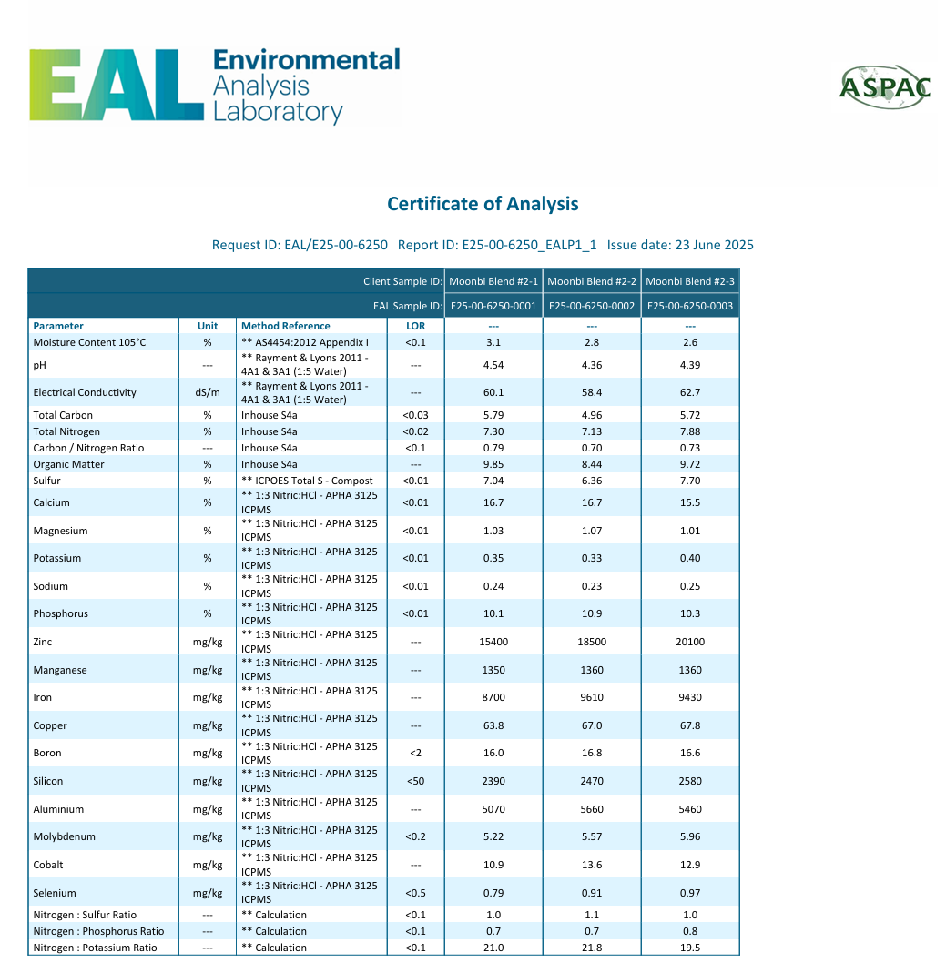

4.2 Demonstration 2. The influence on yield using Groundworks-Bio Microbials (GW) applied to seed pre plant compared to the standard.

Treatment 1 – Growers standard
Lancer wheat planted with Starter Z applied at 30kg/ha. Fungicide was also applied at recommended rates

Treatment 2 – Groundwork-Bio Microbials applied to seed pre plant. No fungicides.

The pre seed application of Groundworks -Bio microbials were applied as follows;
1kg of Groundworks-Bio applied in 10 lts of water to treat 1 tonnes of wheat seed.
The Groundworks-Bio solution was applied to the wheat seed via a venturi in an auger as the seed was augered through to the planting hopper.

4.3 Trial site
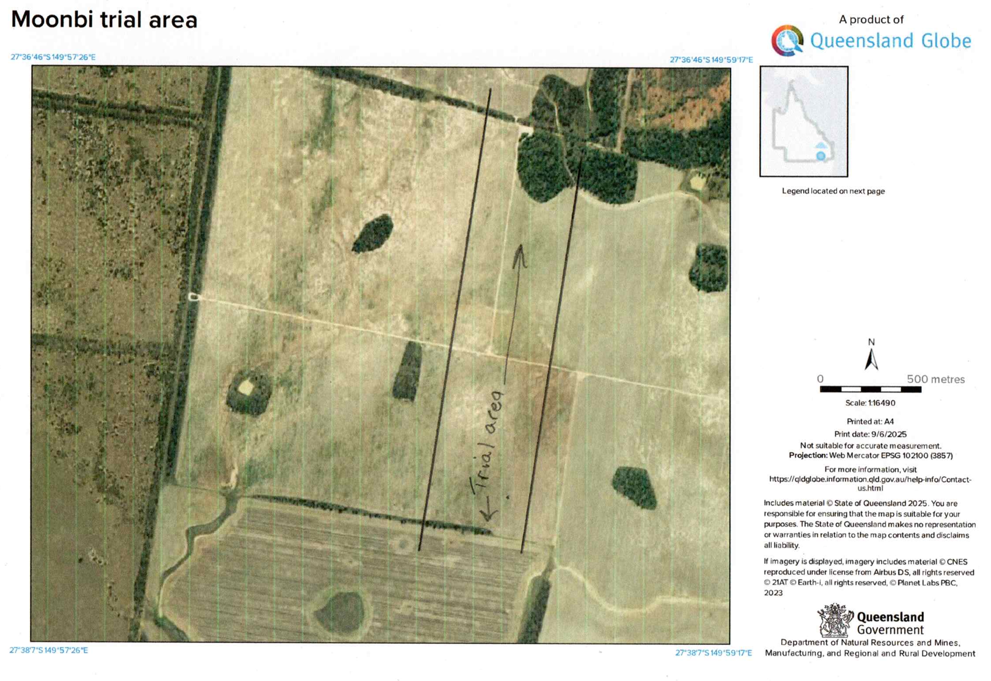
Fig 1. The 2 demonstrations were applied to this portion of “Moonbi”

4.4 Soil Type within the demonstration area
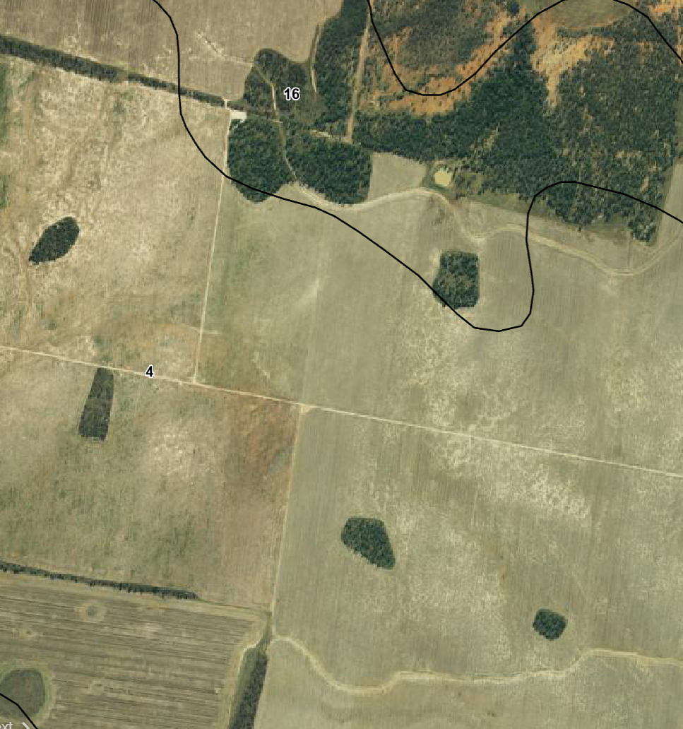
Fig 2. Soil type within demonstration area
Soil type – Cracking clay Vertisol – (>95% of the demonstration area).
Very deep, brown to grey cracking clay with moderately to very deep gilgai’s.

4.5 Treatment map
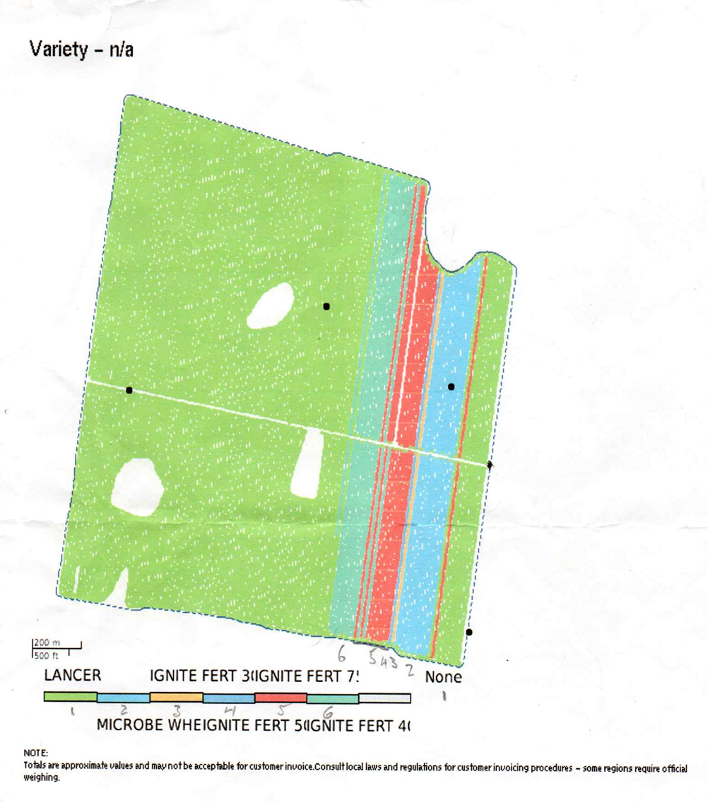
Fig 3. Demonstration treatment layout
Demonstration 1
1 std, 3 (30kg MB/ha),4 (50kg MB/ha),5 (75kg MB/ha) and 6 (40kg MB/ha)
Demonstration 2
1 std, 2 (GW on seed)

4.6 Demonstration Details
Wheat variety – Lancer
Planting data – 9 to 10/05/2025
Harvest date 25 – 26 10/2025
Rainfall – 84.9mm

5.0 Results

5.1 Soils data
Table 2. Soils Data pre and post demonstration
Trt No | Pre Demo | T1 | T2 | T3 | T4 | T5 | T6
Date Sampled | 04/02/25 | 15/10/25 | 15/10/25 | 15/10/25 | 15/10/25 | 15/10/25 | 15/10/25
Block Description | Moonbi BioIgnite demo | Control | Seed  Microbes | 30kg/ha | 50kg/ha | 75kg/ha | 40kg/ha
Sampled depth | Shallow | Shallow | Shallow | Shallow | Shallow | Shallow | Shallow
PH (water) | 8.51 | 7.64 | 8.12 | 7.9 | 8.09 | 7.99 | 8.53
CEC (meq/100g) | 32.45 | 22.4 | 32.9 | 30 | 28.7 | 28.3 | 31.9
EC (dS/m) | 0.24 | 0.088 | 0.712 | 0.339 | 0.216 | 0.0095 | 0.161
Ca (meq/100g) | 17.45 | 11.3 | 16.4 | 15.2 | 15.1 | 15.3 | 19.9
Mg (meq/100g) | 10.8 | 8.02 | 11 | 10.8 | 10.1 | 9.95 | 8.67
Na (meq/100g) | 3.4 | 2.23 | 4.32 | 3 | 2.45 | 1.48 | 2.06
ESP (%) | 10.4 | 9.9 | 13 | 10 | 8.5 | 5.2 | 6.5
Si bses (mg/kg) | 64.8 | 107 | 61 | 59 | 51 | 84 | 68
OC (%) | 0.6 | 0.58 | 1 | 0.8 | 0.83 | 0.91 | 0.83
PBI | 64 | 34 | 49 | 47 | 50 | 95 | 96
Colwell P (mg/kg) | 13.8 | 23 | 37 | 34 | 36 | 37 | 21
Exc K (meq/100g) | 0.75 | 0.89 | 1.15 | 0.98 | 0.97 | 1.51 | 1.25
Sulphur (MCP) mg/kg | 8.2 | 7.6 | 27 | 14 | 10 | 4.1 | 6.1
Copper DTPA (mg/kg | 1.4 | 1.7 | 2.2 | 2.7 | 2.7 | 2.3 | 1.3
Zinc (DTPA) mg/kg | 0.28 | 0.8 | 0.6 | 0.6 | 0.6 | 0.7 | <0.5
Manganese (DTPA) mg/kg | 6.25 | 51 | 12.9 | 13.4 | 10.8 | 12.6 | 15
Boron (CaCl2) mg/kg | 1.05 | 0.57 | 0.89 | 0.85 | 0.8 | 0.83 | 0.64
Nitrate mg/kg | 11.2 | 2.5 | 19 | 8 | 1.7 | 2.5 | 3.6
Ammonium mg/kg | 1.1 | 1 | 1.6 | 1.2 | 2.2 | 1.3 | 1.3

Fig 4. Effect of treatment on soil ESP %

5.2 Grain sample data
Table 3. Grain sample data
Trt Number | T1 | T2 | T3 | T4 | T5 | T6
Date Sampled | 15/10/25 | 15/10/25 | 15/10/25 | 15/10/25 | 15/10/25 | 15/10/25
Block Description | Control | Seed  Microbes | 30kg/ha | 50kg/ha | 75kg/ha | 40kg/ha
Total N %w/w | 1.45 | 1.68 | 2.08 | 1.79 | 1.84 | 1.72
Nitrate N mg/kg | <30 | <30 | <30 | <30 | <30 | <30
Sulfur total %w/w | 0.1 | 0.11 | 0.13 | 0.11 | 0.12 | 0.11
Phosphorus %w/w | 0.27 | 0.3 | 0.26 | 0.23 | 0.27 | 0.25
Potassium %w/w | 0.508 | 0.561 | 0.565 | 0.51 | 0.499 | 0.541
Magnesium %w/w | 0.14 | 0.16 | 0.15 | 0.13 | 0.18 | 0.13
Calcium %w/w | 0.068 | 0.087 | 0.077 | 0.064 | 0.111 | 0.067
Sodium %w/w | 0.032 | 0.12 | 0.061 | 0.045 | 0.17 | 0.023
Chloride %w/w | 0.15 | 0.37 | 0.25 | 0.17 | 0.55 | 0.12
Iron Total mg/kg | 48 | 45 | 46 | 43 | 47 | 51
Aluminium mg/kg | 23 | 14 | 14 | 15 | 15 | 23
Mangenese mg/kg | 84 | 97 | 79 | 56 | 110 | 89
Boron mg/kg | 2.3 | 1.7 | 2.3 | 1.5 | 2.6 | 1.7
Copper mg/kg | 3.3 | 3.9 | 4.8 | 4.1 | 4.4 | 3.8
Zinc mg/kg | 20 | 29 | 16 | 22 | 35 | 15
Moly mg/kg | 0.57 | 0.65 | 0.59 | 0.71 | 0.59 | 0.29

Fig 4. Effect of treatment on Total N %

5.3 Grain Yield
Table 4 Grain yield data
Trt Number | T1 | T2 | T3 | T4 | T5 | T6
Date Harvested | 25/10/25 | 25/10/25 | 25/10/25 | 25/10/25 | 25/10/25 | 25/10/25
Block Description | Control | Seed  Microbes | 30kg/ha | 50kg/ha | 75kg/ha | 40kg/ha
Demo area Ha | 3.57 | 5.25 | 1.65 | 1.66 | 1.69 | 2.02
Tonnes harv t | 12.93 | 15.58 | 6.25 | 6.64 | 6.54 | 7.75
Yield t/ha | 3.62 | 2.97 | 3.8 | 4 | 3.9 | 3.8

Fig 5. Effect of treatment on grain yield t/ha

6.0 Summary Points
- There appears to be a beneficial effect on soil exchangeable sodium % (ESP) with using increased rates of Moonbi Blend fertiliser. The calcium in the MB fertiliser helps to displace sodium and hence reduce sodicity. This has a benefit on the ability of the soil to become friable and hence allow for better nutrient and water utilisation from unrestricted root growth in less compacted profiles.
- In demonstration 1 it was observed that all plots where the Moonbi Blend was applied achieved grain yields greater than that of the standard.
- The total nitrogen % was greater in the plots where Moonbi Blend was applied.
- In demonstration 2 the yield in the plot where GW microbes were applied to the seed was less than the standard. Grain total nitrogen % was however greater.

Appendix - Raw data

